DreamCatcher Horse Ranch & Rescue Center Inc.
Annual Gift Giving Fundraiser
Dear Friend/Fellow Animal Lover,
We are reaching out to you with empty pockets and hopeful hearts. Our facility has been open for 6 years and we have saved the lives of more than 100 horses that were starved, abused and/or abandoned.
Our mission is to help prevent cruelty and neglect of all horses and to rescue horses in need in our community if requested by local animal services, the sheriff’s dept., or those horses simply abandoned and unwanted. We accept horses into our care for rehabilitation as a last chance prior to euthenisatia.
As you can imagine our mission is very costly and we can only continue to operate through the generosity of people like you. Our aim is to rescue and rehabilitate at least 20 horses in 2016. To do so we urgently need funds. Upon arrival at the ranch the rescued horses usually need urgent medical care which includes an evaluation from our Vet to identify their individual health needs and establish their continuing dietary needs. Expenses for a new rescue can range from $500 to $1000+ just for the first month after arrival.
We need your help. How can your donation help?
- A one-time gift - any amount - even $10 helps with feed costs.
- $50 will pay for an 800# bale of hay which will feed 1 rescued horse for a month.
- $100 will pay for grain which will feed 1 rescued horse for a month.
- $250 provides for an evaluation, essential Vet care, vaccinations & dental care for a new rescue.
- $500 will provide complete care and shelter for a new rescue for their first month at the rescue.
- Sponsor a rescued horse monthly (3 month minimum) $25, $50, $100, or any amount per month.
- $75 - Give a gift in someone’s name. You will receive an 8x10 photo and certificate showing the rescued horse you are helping, or we can send everything directly to the recipient. A great Christmas or Birthday Gift idea!

*ALL DONATIONS ARE TAX DEDUCTIBLE* Thank you for your generosity today

Non Profit 501©3 facility - Tax ID 32-0283874
MAIL DONATIONS TO: 10627 Toad Rd, Clermont FL 34715
Tel 407 702 8332 or 352 398 5491
www.DreamCatcherHorses.com email DCHorses1@gmail.com
Make checks payable to Dreamcatcher Horse Ranch Rescue
Please detach and return with your gift
- My one time gift today is _____________________________________________________
- I would like to sponsor a rescued horse for _______months. $ ________________ enclosed.
- I would like to give a gift in someone’s name: $_______To:___________________________
Send photo & Certificate to: ___________________________________________________
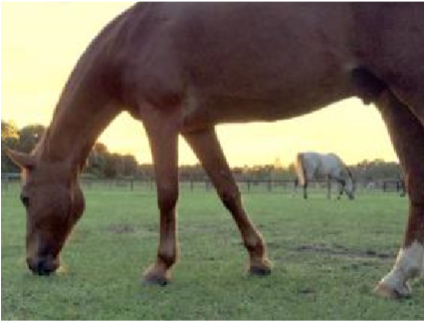
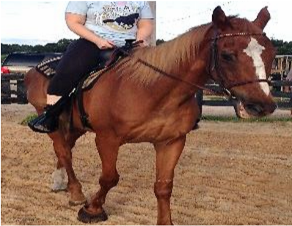
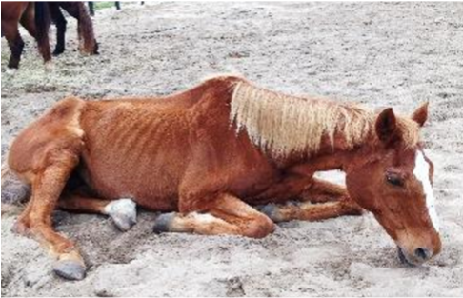
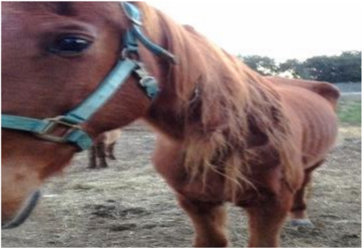

_______________________________________________________________________________________________________

Rusty Before

Sam

Before

Rusty
Today

Sam Today

